
Play with our smart app!
Now you as a player at our course can easily use our smart protocol app.

The app runs in the browser – you don't have to install it, but if you want, you can put it on the home screen and you'll get an app icon and it behaves just like a regular installed app.
If you log in with Facebook, you get access to more features such as betting tips, top lists, game history, statistics and team play.

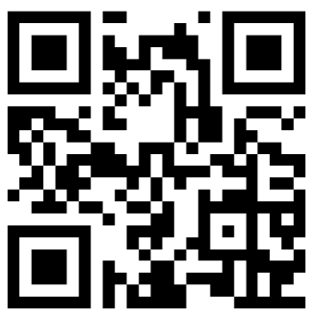
Open your phone's web browser (e.g. Chrome or Safari) and go to app.mgolfapp.com, or scan the QR code.
Choose course, add players and start playing!

If you do not automatically get the nearest facilities, it is probably a setting in your phone where you do not allow location services in the browser.

In Safari, you often use the share function to put the app on the home screen.

